
SokoSmart: A Machine Learning System for Demand Forecasting and Inventory Management in Fashion Micro-Retail
By: Keziah Ndanu Masai
Admission: 24ZAD109796
A Project Proposal Submitted in Partial Fulfilment of the Requirements for the Degree of Computer Science, School of Computing Sciences Riara University Nairobi, Kenya.
July 20, 2026
riara university
Course Code RBCS 7410

DECLARATION
I declare that this or any other University has not previously submitted this work for the awarding of the course marks. I also declare that I will only present this project once the supervisor has approved and signed the document.
To the best of my knowledge and belief, this work contains no material previously published or written by another person except where due reference is made.

(add student name) ………………………………………….

(add signature) ………………………………………….

(add date) ………………………………………….

APPROVAL
This project proposal/ final project / dissertation of student was conducted under our supervision and is submitted with our approval as university supervisors.

Supervisor Name: ………………..

Signature: …………………

Date: ……………………

Contents
DECLARATION ii
ABSTRACT v
DEFINITION OF TERMS vii
LIST OF ABBREVIATIONS viii
LIST OF FIGURES ix
LIST OF TABLES x
Chapter One 1
1.1. Problem Statement 1
1.2. Objectives of the Study 2
1.3. Justification 2
1.4. Scope 3
Chapter Two 4
2.1. Introduction 4
2.2. Inventory Management in Small Scale Retail 4
2.3. Demand Forecasting Using Machine Learning 7
2.4. Inventory Optimization Techniques 10
2.5. Conversational AI and WhatsApp-Based System Deployment 11
2.6. Conclusion 12
Chapter Three 13
3.0. Introduction 13
3.1. System Development Methodology 13
3.2 Requirements Gathering 14
3.3 System Design 18
3.4 Technical Requirements 25
3.5 Project Budget 29
3.6 PROJECT TIMELINE (GANTT CHART) 31
References 31
APPENDIX A: STRUCTURED OBSERVATION NOTES 33

DEFINITION OF TERMS
ARIMA (Autoregressive Integrated Moving Average) – A statistical model used in SokoSmart to predict future sales from past sales data.
Dynamic Reorder Point (ROP) – A stock level that changes according to expected demand and is used to decide when to reorder.
EOQ (Economic Order Quantity) – A method used to estimate an appropriate quantity of stock to order while considering ordering and storage costs.
Flask – A Python framework used to build the backend of SokoSmart.
LSTM (Long Short-Term Memory) – A neural network model used to identify patterns in sales data over time.
Machine Learning – The use of data to identify patterns and make predictions. SokoSmart uses it for demand forecasting.
MAE (Mean Absolute Error) – A measure of the average difference between predicted and actual sales values.
MAPE (Mean Absolute Percentage Error) – A measure of forecasting error expressed as a percentage.
RMSE (Root Mean Square Error) – A forecasting error measure that gives more weight to larger prediction errors.
Safety Stock – Extra stock kept to reduce the chance of running out of a product.
Scrum – The Agile framework used to organise the development of SokoSmart into sprints.
SokoSmart – The system developed in this project to forecast product demand and provide inventory alerts to fashion vendors through WhatsApp.
Stockout – A situation where a product is unavailable when a customer wants to buy it.
Twilio WhatsApp Business API – The service used to connect SokoSmart with WhatsApp.
Webhook – A method used to send incoming WhatsApp messages from Twilio to the SokoSmart backend.
XGBoost (Extreme Gradient Boosting) – A machine learning model used to predict sales by combining several decision trees.

LIST OF ABBREVIATIONS
Abbreviation | Full Term
API | Application Programming Interface
ARIMA | Autoregressive Integrated Moving Average
CAK | Communications Authority of Kenya
CBD | Central Business District
DFD | Data Flow Diagram
EAT | East Africa Time
EOQ | Economic Order Quantity
ERP | Enterprise Resource Planning
ERD | Entity Relationship Diagram
FR | Functional Requirement
GDP | Gross Domestic Product
HTTP | Hypertext Transfer Protocol
HTTPS | Hypertext Transfer Protocol Secure
IHL | Inventory Holding Loss
KES | Kenyan Shillings
KNBS | Kenya National Bureau of Statistics
LSTM | Long Short-Term Memory
MAE | Mean Absolute Error
MAPE | Mean Absolute Percentage Error
MSME | Micro, Small and Medium Enterprise
NFR | Non-Functional Requirement
ORM | Object Relational Mapper
POS | Point of Sale
RAD | Rapid Application Development
RMSE | Root Mean Square Error
ROP | Reorder Point
SDK | Software Development Kit
SHA | Secure Hash Algorithm
SME | Small and Medium Enterprise
SQL | Structured Query Language
TLS | Transport Layer Security
XGBoost | Extreme Gradient Boosting

LIST OF FIGURES
Figure 1 use case diagram 32
Figure 2 Block diagram 33
Figure 3 Data Flow Diagram 34
Figure 4 Entity relationship diagram 35

LIST OF TABLES
Table 1 Characteristics of all the three models 22
Table 2 organization of the sprints 27
Table 3 identified non-functional requirements 28
Table 4 identtified functional requirements 30
Table 5 Data Dictionary 36
Table 6 Hardware Requirements 39
Table 7 programming languages 39
Table 8 Frameworks and Libraries 39
Table 9 Development Tools 40
Table 10 Cloud Deployment Tools 40
Table 11 Hardware requirements 41
Table 12 Software Requirements 41
Table 13 Budget 42
Table 14 Gantt Chart SokoSmart Development Schedule 43

CHAPTER ONE

1.1. Problem Statement
Small-scale fashion vendors in Gikomba, Eastleigh, Toi Market, and the Nairobi CBD run businesses shaped by demand patterns they can observe but cannot easily predict. Demand may increase before schools reopen, rise around end-of-month salary periods, or fall when a particular fashion trend loses popularity. Many vendors still track their stock using notebooks, basic phone notes, or memory. Ideally, vendors should be able to use their own sales history to anticipate demand and make better decisions about when and what to restock.
The problem is that few existing tools provide this ability in a form that is practical for small informal vendors. Platforms such as Shopify and QuickBooks provide inventory management features, but they are generally designed for businesses with access to computers, reliable internet, and users who are comfortable working with digital dashboards. These conditions may not reflect the situation of many vendors in Nairobi's informal markets. Without an affordable and accessible forecasting tool, vendors have to rely mainly on their own judgement when deciding how much stock to purchase. Overstocking can tie up limited working capital, while stockouts can result in lost sales when customers purchase the same products from nearby competitors. Globally, inventory mismanagement is estimated to cost retailers approximately $1.75 trillion annually (IHL Group, 2023).

1.2. Objectives of the Study

1.2.1. General Objective

To develop a machine learning-based demand forecasting and inventory management system for small-scale fashion vendors in Nairobi, Kenya, using a WhatsApp chatbot interface.

1.2.2. Specific Objectives
- To identify the inventory management challenges and information needs of small-scale fashion vendors in selected Nairobi markets through literature review and market observation.
- To develop SokoSmart using ARIMA, XGBoost, and LSTM forecasting models, reorder-point calculations, inventory alerts, and a WhatsApp chatbot interface using Twilio and Flask.
- To evaluate the forecasting performance of the implemented models using RMSE, MAE, and MAPE.
- To assess the usability of the SokoSmart WhatsApp chatbot through user testing.

1.3. Justification
Kenya's informal fashion retail sector makes an important contribution to the country's economy, yet many vendors still rely on manual methods to manage inventory. Most make stocking decisions using notebooks, memory, or experience because affordable forecasting tools are not available to them. This creates unnecessary financial losses. Globally, inventory mismanagement is estimated to cost retailers about $1.75 trillion each year (IHL Group, 2023), and the impact is often greater for micro-enterprises because they have limited working capital and fewer resources to recover from poor inventory decisions.
Research has shown that machine learning-based forecasting can reduce inventory-related costs by 20–50% in comparable retail environments (Fildes et al., 2022). However, that capability has not reached most Kenyan fashion micro-vendors. Existing commercial platforms such as Shopify and QuickBooks remain difficult to adopt because of their cost and technical complexity. This project responds to that gap by developing SokoSmart, which delivers machine learning-powered forecasting through WhatsApp. Since most vendors already use WhatsApp in their daily business activities, the system does not require additional hardware, separate software installation, or specialised technical training (Communications Authority of Kenya, 2024).
This study is justified for three main reasons. First, the financial impact of poor inventory management is well documented and affects many small businesses. Second, machine learning forecasting has already proven effective in improving inventory decisions in comparable retail settings. Finally, delivering the solution through WhatsApp increases the likelihood that small-scale fashion vendors can use the technology without changing how they already operate their businesses.

1.4. Scope
SokoSmart does not cover everything, but it covers the following. In terms of functionality, the system covers demand forecasting and automated inventory reorder alerts only. Payment processing, supplier management, POS hardware, and financial reporting are excluded from the project.
For data, training and evaluation it will use publicly available fashion retail sales datasets augmented with locally relevant parameters. The collection of live vendor transaction data is not within the scope of the project.
Regarding the interface, the WhatsApp chatbot supports text-based interactions only. Voice input, image-based stock capture, and multi-language support beyond English are excluded from the current system.
From a technology perspective, the system uses Python open-source libraries, including scikit-learn, TensorFlow, and statsmodels, together with a Flask backend and the Twilio WhatsApp Business API. The system will be deployed using Render or Railway cloud hosting.
Geographically, the project focuses on Nairobi County, Kenya, specifically targeting fashion vendors operating in Gikomba, Eastleigh, Toi Market, and the Nairobi CBD. The intended users are individual fashion micro-vendors who operate their businesses through smartphones with standard mobile data. No prior technical background is required to use the system.
Finally, the success of the system will be measured using RMSE, MAE, and MAPE to evaluate forecasting accuracy. The usability of the WhatsApp interface will also be assessed through structured testing with representative users.

CHAPTER TWO

2.1. Introduction
The development of SokoSmart, a machine learning-based demand forecasting and inventory management system for small-scale fashion vendors in Nairobi, Kenya, brings together several areas of research and applied computer science. Developing the system required looking at the challenges faced by small retailers as well as the technologies that could be used to address some of those challenges. This chapter reviews the literature that forms the theoretical and technical basis of the study.

2.2. Inventory Management in Small Scale Retail
Inventory management is a core function of every retail business. It involves ordering, storing, tracking, and controlling stock so that customer demand can be met while keeping inventory costs under control. Large retailers usually rely on enterprise resource planning (ERP) systems and dedicated supply chain teams to manage these activities. In contrast, small and micro-scale retailers, particularly those operating in informal economies, often depend on manual record keeping, personal experience, and intuition. Their inventory decisions are therefore more reactive than predictive, making it harder to respond to changes in demand. This difference has a direct impact on business performance, profitability, and long-term sustainability.
The main challenge for small retailers is balancing two competing risks. The first is overstocking, where more inventory is purchased than customers are likely to buy. This ties up working capital, increases storage costs, and, in fashion retail, creates the additional risk of products becoming outdated as trends change (Ren et al., 2020). The second is understocking, which occurs when demand exceeds the available stock. Stock shortages lead to lost sales, dissatisfied customers, and increased competition from nearby businesses. According to Kharfan et al. (2020), these challenges are even greater in fashion retail because demand changes quickly with seasons and consumer preferences. Missing the right time to restock can mean losing sales for an entire season. For small vendors operating with limited capital and restricted access to credit, either situation can have serious financial consequences.
Traditional inventory management practices in small retail include periodic manual stock counts, rule-of-thumb reorder decisions, and experience gained through years of trading. While these approaches remain useful in day-to-day operations, they are less effective in environments where demand changes frequently, product ranges are large, and seasonal buying patterns are common. This creates a clear disadvantage for small retailers because important inventory decisions are made without analytical support. Ferreira et al. (2016) demonstrated the benefits of data-driven inventory management using an online retailer with extensive transaction records. However, whether similar methods can achieve comparable results for micro-vendors who maintain only limited manual records remains an important research question and provides part of the motivation for this study.

2.2.1. Inventory Management Challenges in Developing Economy Retail
The inventory management challenges faced by small retailers in developing economies differ from those reported in high-income countries. In Sub-Saharan Africa, and particularly in Kenya, small fashion vendors deal with more than demand fluctuations and seasonal changes. They also face practical challenges such as unreliable electricity, limited internet connectivity, high mobile data costs, and the absence of formal point-of-sale systems that can generate the transaction data needed for informed inventory decisions (Wanjiru & Ngugi, 2021).
Wanjiru and Ngugi (2021) examined inventory management practices among SMEs in Nairobi County and found that most small retailers still relied on notebooks or simple mobile phone reminders to monitor stock levels. Their study also reported that structured inventory management practices were positively associated with better financial performance, showing that poor inventory practices have measurable economic consequences for small businesses. However, the study focused on observing existing practices rather than testing whether digital tools could improve inventory management.
The informal retail environment in Nairobi introduces additional challenges. Vendors operating in markets such as Gikomba, Eastleigh, Toi Market, and the CBD serve diverse customer groups whose purchasing behaviour changes throughout the year. Demand is influenced not only by seasonal trends but also by salary payment cycles, school calendars, and the presence of nearby competitors (Omwenga et al., 2020). These local factors are rarely represented in forecasting models developed using retail data from high-income countries. This highlights the need for a forecasting system that reflects the realities of Kenya's informal fashion retail sector. Although Omwenga et al. (2020) identified these local demand patterns, their study did not develop or evaluate a technical solution that vendors could use through smartphones.
Another challenge is the digital divide within Kenya's informal retail sector. Many existing inventory management systems assume that businesses have access to desktop computers, reliable broadband internet, or staff with technical skills. These assumptions do not reflect the reality faced by many small vendors. The Communications Authority of Kenya (2024) reports that smartphone ownership and WhatsApp use are widespread among informal traders in Nairobi, whereas laptop ownership and fixed broadband access remain limited. For this reason, SokoSmart is designed to operate entirely through smartphones using WhatsApp. However, the CAK report measures access to devices rather than how vendors use them for business activities. High WhatsApp adoption does not necessarily mean that vendors will automatically use a chatbot for inventory management, making user acceptance an important consideration for this study.

2.3. Demand Forecasting Using Machine Learning

Demand forecasting in retail has changed considerably over the last two decades. Classical statistical methods such as simple moving averages, exponential smoothing, and Autoregressive Integrated Moving Average (ARIMA) models were widely used during the 1990s and 2000s, especially in retail environments with relatively stable demand patterns. However, these methods are less effective in fashion retail, where trends can change quickly and demand spikes such as those occurring around salary periods often differ sharply from normal sales patterns.

As retail datasets became larger and computing power became more accessible, machine learning and deep learning approaches began to compete with, and often outperform, traditional statistical methods. This is particularly evident in environments characterized by non-linear demand patterns, multiple influencing factors, and a high variety of products. Even so, most of the reported performance advantages have been demonstrated in data-rich settings, and it remains uncertain how well these models perform when historical records are limited.

Swaminathan et al. (2023), in a systematic review of demand forecasting methods for fashion products published in the International Journal of Forecasting, found that machine learning and deep learning models consistently outperformed classical statistical approaches across several fashion retail datasets. The performance gap became larger as product variety and demand volatility increased. The authors identified LSTM neural networks and gradient boosting methods as among the strongest-performing model families for fashion-specific forecasting tasks, noting that their ability to capture non-linear relationships and complex seasonal patterns gave them an advantage over ARIMA-type models in volatile retail environments. However, the review was based mainly on studies conducted in developed markets with strong data infrastructure, making it unclear whether the same advantage is maintained under data-scarce conditions.

Ren et al. (2020) examined demand forecasting for fashionable products in retail operations and found that integrating additional data sources such as social media trend signals, weather data, and promotional calendars into machine learning models produced substantially more accurate forecasts than relying on historical sales data alone. Their findings highlight both the potential of machine learning-based forecasting and the practical challenge faced by micro-vendors who do not have access to such enriched datasets. For SokoSmart, this creates an important design challenge: the forecasting system must still produce useful results even when only limited historical data is available.

2.3.1. Comparative Analysis of Forecasting Models: ARIMA, XGBoost, and LSTM
SokoSmart uses three forecasting models ARIMA, XGBoost, and LSTM to represent different approaches to demand forecasting, ranging from traditional statistical techniques to modern machine learning and deep learning methods. Comparing these models helps explain why they were selected for the system and provides a basis for interpreting the forecasting results presented later in this study.
ARIMA (Autoregressive Integrated Moving Average) is one of the most widely used statistical models for time series forecasting. It predicts future values by analysing patterns in historical sales data through autoregressive and moving average components. Because of its simplicity, interpretability, and relatively low computational requirements, ARIMA continues to be used in many retail forecasting applications (Makridakis et al., 2018). Its main limitation is the assumption that relationships within the data are largely linear. In fashion retail, where demand is influenced by changing trends, promotions, and other external factors, this assumption can reduce forecasting accuracy. Within SokoSmart, ARIMA provides a baseline against which the machine learning models are evaluated. Its performance also depends on the availability of clean and consistent historical sales records, something that many vendors using manual record-keeping may not have.
Unlike ARIMA, XGBoost (Extreme Gradient Boosting) is a machine learning algorithm that combines multiple decision trees to improve prediction accuracy. Each new tree is built to reduce the errors made by the previous ones, allowing the model to learn complex relationships within structured data. Swaminathan et al. (2023)identified gradient boosting techniques among the strongest-performing approaches for fashion demand forecasting because they can use multiple variables at the same time. Loureiro et al. (2018) also demonstrated that advanced learning models can improve sales forecasting accuracy in fashion retail, suggesting that structured ensemble methods such as XGBoost are well suited to similar forecasting tasks. For SokoSmart, this flexibility is important because the model can incorporate factors such as the day of the week, month, promotional activities, and product category when generating forecasts.
LSTM (Long Short-Term Memory) networks represent the deep learning approach used in this project. As a specialised form of recurrent neural network, LSTM is designed to learn long-term patterns within sequential data, making it suitable for forecasting demand that changes over time. Giri et al. (2022) reported that LSTM models captured complex seasonal behaviour and irregular demand patterns more effectively than both ARIMA and traditional machine learning methods in fashion forecasting simulations. Similarly, Seyedan et al. (2023) found that deep learning models incorporating LSTM components produced greater reductions in inventory costs than non-deep learning alternatives in online retail environments. The trade-off is that LSTM requires more computational resources and larger volumes of historical data during training. Although this does not affect real-time forecasting after deployment, it may reduce performance when vendors have only limited historical sales records.
The table summarises the main characteristics of the three forecasting models, highlighting their strengths, limitations, and suitability for the operational requirements of SokoSmart.
Table 1 Characteristics of all the three models
Dimension | ARIMA | XGBoost | LSTM
Model type | Statistical | Ensemble ML | Deep learning
Handles non-linearity | No | Yes | Yes
Multi-variable input | Limited | Yes | Yes
Captures long-term patterns | Partially | Partially | Yes
Interpretability | High | Moderate | Low
Data requirement | Low | Moderate | High
Computational cost | Low | Moderate | High
Fashion retail performance | Baseline | Strong | Strongest
Suitable for SokoSmart | As baseline | Primary candidate | Primary candidate
The comparison shows that each forecasting model has different strengths and limitations depending on the data and forecasting conditions. For this reason, SokoSmart does not rely on a single model. Instead, the system evaluates ARIMA, XGBoost, and LSTM using RMSE, MAE, and MAPE, then selects the model that provides the most accurate results for deployment. This approach follows the evaluation framework recommended by (Makridakis et al., 2018) for assessing forecasting models in retail environments.

2.4. Inventory Optimization Techniques
Forecasting demand is only part of the inventory management. Vendors also need to decide when to buy more stock and how much to buy. Inventory optimization deals with these decisions. It uses methods from operations research and ML to help with stock management. Two common methods are the Economic Order Quantity (EOQ) model and the Reorder Point (ROP) model. Using these methods together with demand forecasts can make inventory decisions more responsive to changes in demand (Seyedan et al., 2023).
The Economic Order Quantity (EOQ) model is used to find an order quantity by considering ordering costs and holding costs. One limitation of the model is that it assumes demand is constant and predictable. This may not work as well for small retail businesses where demand can change because of seasonal trends and unpredictable buying patterns. Baryannis et al. (2019) found that ML based forecasting generally performed better than static models when demand was highly uncertain. However, their review did not specifically look at micro-retail businesses.
Reorder Point (ROP) model is used to decide when a new order should be made. The traditional calculation uses average daily demand, lead time, and safety stock to reduce the chance of running out of stock. In a system that uses demand forecasts, the reorder point can be changed as the expected demand changes. SokoSmart uses this approach by updating the reorder threshold after each forecasting cycle. The low-stock alert can therefore be based on the current demand pattern instead of using one fixed stock level for every situation.
Hollupathirage (2025)studied a prototype digital twin system for retail inventory and sales management and found that AI-supported reorder point systems with real-time monitoring reduced stockouts compared with manual inventory tracking. The study also reported a reduction in excess inventory. The digital twin system used in the study is more advanced than the approach used in SokoSmart, so its results cannot be used to directly prove that SokoSmart will produce the same results. However, the findings are relevant to the idea of using forecasts to make reorder decisions instead of depending only on manual stock tracking. This is the approach used for the low-stock alert feature in SokoSmart.

2.5. Conversational AI and WhatsApp-Based System Deployment
SokoSmart delivers its forecasting and inventory functions through a WhatsApp chatbot. I made this choice based on what I observed during the sessions across the four target markets: smartphones were universally in use, but most vendors were seen using no inventory application, spreadsheet, or point-of-sale system. WhatsApp, by contrast, appeared on almost every screen. Based on these observations, I felt that requiring vendors to download and learn a separate application could create an unnecessary barrier.
Selamat and Windasari (2021) examined chatbot adoption among small business owners and found that natural language interaction lowered technology barriers for users without software training. Their research centered on customer service rather than stock control, yet the finding is transferable: when a system communicates through ordinary text rather than dashboards or forms, the user does not need to learn any system conventions. A vendor who can read a message stating that her stock of a particular item will likely deplete within three days can act on that information immediately, without interpreting or navigating menus and chats.
WhatsApp's position in Kenyan informal sectors makes this practical. The Communications Authority of Kenya (2024) documents near-universal WhatsApp usage among informal traders in Nairobi. Jack & Suri (2014) traced how M-Pesa reached non-technical users by operating through the mobile phones they already owned; Aker & Mbiti (2010) noted that mobile platforms across sub-Saharan Africa succeeded precisely because they did not require users to acquire new devices or skills. SokoSmart follows that precedent by placing inventory forecasting inside an application that vendors already check repeatedly throughout the trading day.
This integration is intended to address the stock management problem directly. With manual systems, a vendor may only realise that an item is running out when a customer asks for it or when a physical stock count shows that it is no longer available. The WhatsApp chatbot changes this process by using the available stock information to generate forecasts and send alerts before the predicted depletion point. Since the warning appears in the same application the vendor already uses to communicate with suppliers, the vendor can act on it without having to switch to another system.
The Twilio WhatsApp Business API provides the messaging infrastructure, routing vendor inputs to the Flask backend and returning system responses. Development can proceed within Twilio's sandbox environment, avoiding the need for a verified business account during the prototype phase. Deployment on Render or Railway supplies cloud hosting at low cost, though existing literature has not yet documented this particular combination of technologies for inventory management in informal retail settings.

2.5.1 Mobile First Systems in Kenyan Informal Retail
Kenya's informal economy has already shown that mobile-first platforms can work. M-Pesa proved this back in 2007 it spread to non-technical users who did not even own smartphones at the time, and later grew into smartphone-based business tools (Jack & Suri, 2014). Aker and Mbiti (2010) make a similar point: mobile phones across sub-Saharan Africa cut transaction costs and opened markets that small traders could not previously reach. The Communications Authority of Kenya (2024) shows this trend has held almost every informal trader in Nairobi now has a smartphone and uses WhatsApp. But here is the problem Wanjiru and Ngugi (2021) identify: having a phone has not changed how vendors manage stock. They still use notebooks and memory, even though the device in their pocket could do far more. That gap between owning the technology and using it for business operations is exactly where SokoSmart sits. M-Pesa handled money. WhatsApp handled messaging. Nobody has built a mobile-first tool for demand forecasting and inventory control aimed at these vendors. SokoSmart tries to fill that space.

2.6. Conclusion
This chapter reviewed four main areas related to the development of SokoSmart: inventory management practices among small retailers, machine learning approaches to demand forecasting, reorder point models for inventory decisions, and the use of chatbots to improve system accessibility. The review shows that these areas have been studied extensively, but much of the existing work focuses on businesses with reliable data, better digital infrastructure, and access to technical expertise. These conditions are different from those faced by many small vendors operating in Nairobi's informal markets.
The literature reviewed also shows that machine learning can provide better demand forecasts than traditional approaches. However, many of these studies use large and well-organised transaction datasets. This leaves a question about how well models such as LSTM and gradient boosting will work when the available records are small, incomplete, or irregular, as is common with manual record keeping.
The same issue appears in inventory optimization. Dynamic reorder point methods can support better stock decisions, but existing implementations often depend on systems and infrastructure that may not be practical for informal retailers. Chatbots offer another possible way of making digital systems easier to access, but their use for inventory management among informal retailers in African markets has received limited attention.
From the review, the main gap identified is the lack of a single system that brings together demand forecasting, inventory optimization, and chatbot interaction for small-scale fashion vendors in a developing-economy setting. SokoSmart was developed in response to this gap. The system combines these components and makes them available through WhatsApp, with the intention of making demand forecasting and inventory decisions easier for vendors who may not have access to more complex digital systems.

CHAPTER THREE

3.0. Introduction
This chapter explains how SokoSmart is being designed and developed. It is divided into six sections. The first section explains the choice of Agile Scrum as the development methodology. The second covers the requirements, including how they were collected and the functional and non-functional requirements identified from the process.
The third section presents the system design using four diagrams: the block diagram, data flow diagram, entity relationship diagram, and use case diagram. Each diagram is explained in relation to the system. The fourth describes the hardware, software, and security requirements needed during development and for the end user. The fifth presents the project budget, while the sixth provides the ten-week timeline using a Gantt chart.
Together, these sections describe how SokoSmart is structured and how it is expected to be developed, while taking into account the conditions and needs of fashion vendors in Nairobi.

3.1. System Development Methodology
System development methodologies provide a structured way of planning, developing, testing, improving, and deploying software. For SokoSmart, Agile using the Scrum framework was selected because the project has several components that need to be developed and tested in stages. These components include the demand forecasting models, inventory optimization module, Flask backend, and WhatsApp chatbot. Some parts of the system may also require changes as testing produces new results.

Selected Methodology: Agile Scrum
SokoSmart uses Agile with the Scrum framework. Development is carried out in short cycles, where a part of the system is developed, tested, reviewed, and improved before moving to the next stage. This approach fits SokoSmart because the machine learning component requires experimentation. ARIMA, XGBoost, and LSTM need to be trained and compared using RMSE, MAE, and MAPE before the most suitable model can be selected. The WhatsApp chatbot also requires testing to determine whether the interaction is clear and practical for the intended users.
The development of SokoSmart was divided into four sprints, as shown below:

Table 2 organization of the sprints

Sprint | Focus | Duration
Sprint 1 | Requirements gathering, system design, dataset sourcing | 2 weeks
Sprint 2 | Data preprocessing, ARIMA, XGBoost and LSTM model development | 3 weeks
Sprint 3 | Inventory optimization module and Flask API development | 2 weeks
Sprint 4 | WhatsApp chatbot integration, testing, evaluation and deployment | 3 weeks
During Sprint 1, the project focused on understanding the inventory management problem, collecting the system requirements, designing the initial system structure, and finding the datasets needed for forecasting. These activities provided the starting point for the rest of the development work.
Sprint 2 focused on data preparation and demand forecasting. The datasets were prepared for modelling, and the ARIMA, XGBoost, and LSTM models were then developed and tested. Their performance was compared using RMSE, MAE, and MAPE. The results helped determine which forecasting model was most suitable for use in SokoSmart.
In Sprint 3, the inventory optimization component and Flask API were developed. The forecasting results were linked to the inventory logic so that the system could identify when stock reached the reorder point. The Flask API handled the connection between the backend processes and the chatbot interface.
Sprint 4 focused on connecting the WhatsApp chatbot to the backend, followed by system testing, evaluation, and deployment. The different components were brought together at this stage, allowing a vendor to access the forecasting and inventory functions through WhatsApp.
Agile Scrum was chosen because it allowed SokoSmart to be developed in smaller stages instead of waiting until the whole system was finished before testing it. Problems found during model evaluation or chatbot testing could then be addressed while development was still in progress. This approach was useful for SokoSmart because the forecasting component and the user interface require different types of testing, but both still have to work together as one system.

Figure 1Agile Scrum Development Process for SokoSmart
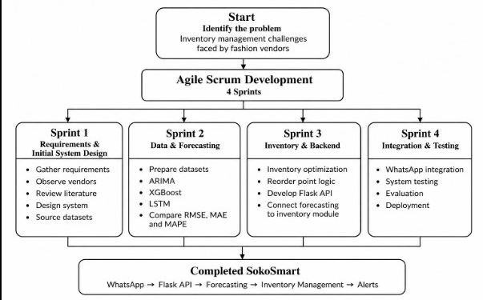

3.2 Requirements Gathering

3.2.1 Collection Method
Requirements were gathered using two main approaches: structured observation of vendors in the target market areas and a review of published literature.

Structured Observation
Direct observation was carried out across the four market areas: Gikomba, Eastleigh, Toi Market, and the Nairobi CBD. The purpose was to understand how small-scale fashion vendors manage their inventory in their day-to-day work. During the observation sessions, the researcher looked at the tools vendors used to keep track of stock, what caused them to restock, and some of the problems that could be seen when inventory was not managed well. These included piles of slow-moving items and empty displays when popular items had run out.
Several patterns were observed:
- Stock tracking: All observed vendors used manual methods such as handwritten notebooks, basic phone notes, or memory. No vendor was observed using a digital inventory tool or spreadsheet.
- Restocking triggers: Restocking was mainly based on seeing that stock was running low or having enough cash to purchase more stock. Vendors were observed counting the items they had left or estimating stock levels by looking at the items on display rather than using a calculated threshold or forecast.
- Overstock evidence: Several stalls had items from previous seasons being sold at reduced prices. This suggested that earlier purchasing decisions had not accounted for changes in demand.
- Stockout evidence: Vendors were observed turning customers away or directing them to nearby stalls when particular sizes or colours were unavailable.
- Technology use: All observed vendors used smartphones. WhatsApp was visible on the screens for supplier communication and customer orders. However, no vendor was observed using an inventory management or POS application.
These observations provided firsthand evidence that the manual, intuition driven inventory practices documented by (Wanjiru & Ngugi, 2021) remain prevalent in the field, and confirmed that the operational context described in Chapter 1 is current and observable rather than purely theoretical.
Literature Review as Secondary Collection
The systematic literature review conducted in Chapter 2 provided secondary evidence that corroborated and extended the observation findings. Studies on inventory management challenges in developing economy retail (Omwenga et al., 2020; Wanjiru & Ngugi, 2021) confirmed the persistence of manual tracking methods and the impact of localised demand drivers. Machine learning forecasting literature (Giri et al., 2022; Makridakis et al., 2018; Swaminathan et al., 2023) established the technical benchmarks for model evaluation and selection. Conversational AI deployment studies (Selamat & Windasari, 2021) and the (Communications Authority of Kenya, 2024) supported the choice of WhatsApp as the delivery channel. Together, observation and literature review provided a complete evidence base for defining SokoSmart's requirements.

3.2.2 Non-Functional Requirements
Non-functional requirements define the quality attributes and operational constraints that SokoSmart must satisfy they describe how the system performs rather than what it does (Pressman & Maxim, 2020). The following non-functional requirements were identified through the requirements gathering process:

Table 3 identified non-functional requirements

 | Requirement | Description | Source
NFR1 | Accessibility | The system must be operable by users with no prior technical training, delivered entirely through WhatsApp text interactions | Field observation + Literature
NFR2 | Performance | Forecast queries submitted via WhatsApp must receive a response within 10 seconds under standard mobile data conditions | Literature
NFR3 | Accuracy | The demand forecasting module must achieve a Mean Absolute Percentage Error (MAPE) of below 15% on test data | Literature
NFR4 | Reliability | The system must maintain at least 95% uptime during operating hours (6am–10pm EAT) | Literature
NFR5 | Scalability | The Flask backend must support at least 50 concurrent WhatsApp user sessions without performance degradation | Literature
NFR6 | Affordability | The system must be deployable on cloud infrastructure costing under KES 2,000 per month. This threshold represents approximately 5–8% of the typical monthly mobile data and communication budget reported by Nairobi informal vendors (Communications Authority of Kenya, 2024), ensuring the operational cost does not impose a financial burden comparable to existing commercial platforms. | Field observation + Literature
NFR7 | Security | Vendor sales data stored or processed by the system must not be shared with third parties and must be handled in compliance with Kenya's Data Protection Act 2019 (Republic of Kenya, 2019) | Legislation
NFR8 | Maintainability | System components ML models, Flask API, WhatsApp integration must be modular and independently updatable without full system redeployment | Literature
NFR9 | Usability | First-time users must be able to complete a stock forecast query without external assistance within 3 minutes of first interaction | Field observation + Literature
NFR10 | Portability | The system must function on any Android or iOS smartphone running WhatsApp version 2.21 or later | Field observation

3.2.3 Functional Requirements
Functional requirements define the specific behaviours, features, and functions that SokoSmart must perform (Sommerville, 2016). They describe what the system must do to satisfy the needs of its users. The following functional requirements were derived from observation findings and literature review:
Table 4 identtified functional requirements
 | Requirement | Description | Source
FR1 | Sales data input | The system must allow vendors to input historical sales data by product category and date through the WhatsApp interface | Field observation
FR2 | Demand forecasting | The system must generate product level demand forecasts for a user specified future period using ARIMA, XGBoost, and LSTM models | Literature
FR3 | Model selection | The system must automatically select and deploy the best-performing forecasting model based on RMSE, MAE, and MAPE evaluation on the vendor's dataset | Literature
FR4 | Inventory tracking | The system must allow vendors to log current stock levels by product category through the WhatsApp interface | Field observation
FR5 | Reorder point calculation | The system must compute dynamic reorder points based on forecasted demand and user-defined lead time, updating automatically with each new forecast cycle | Literature
FR6 | Low-stock alerts | The system must send automated WhatsApp alerts to vendors when current stock levels fall at or below the computed reorder point for any tracked product | Field observation
FR7 | Forecast query | The system must respond to a vendor's natural language WhatsApp query with a plain language forecast summary for the requested product and time period | Field observation
FR8 | Stock status query | The system must respond to a vendor's WhatsApp query with the current stock level, reorder point, and alert status for any tracked product | Field observation
FR9 | Data storage | The system must securely store vendor sales history and stock records for use in model training and reorder calculations | Literature
FR10 | Onboarding | The system must guide a first-time vendor through initial setup product registration, stock level entry, and forecast preference through a structured WhatsApp conversation flow | Field observation

3.3 System Design
The system design for SokoSmart translates the functional and non-functional requirements identified in Section 3.2 into a concrete architectural blueprint. Four diagrams are presented in this section, each capturing a different dimension of the system's structure and behaviour. The block diagram provides a high level overview of the system's major components and their relationships. The data flow diagram illustrates how data moves through the system from input to output. The entity relationship diagram defines the data structures and relationships that underpin the system's storage layer. The use case diagram maps the interactions between the system and its primary users. Together, these four diagrams provide a complete and implementable design specification for SokoSmart (Pressman & Maxim, 2020).

3.3.1 Use Case Diagram
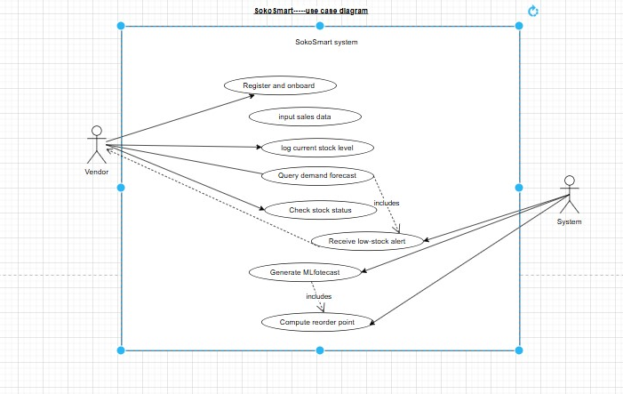
Figure 2 use case diagram
The Use Case Diagram identifies two actors and eight use cases within the SokoSmart system boundary. The Vendor actor, representing the small-scale fashion vendor interacting via WhatsApp, initiates five use cases directly: registering and completing onboarding, inputting historical sales data, logging current stock levels, querying demand forecasts, and checking stock status. These five use cases represent vendor-driven interactions actions the vendor consciously performs by sending a WhatsApp message to the system. The System actor represents SokoSmart's automated backend processes. It initiates three use cases independently: receiving and delivering low-stock alerts to the vendor, generating ML forecasts, and computing dynamic reorder points. The Receive Low Stock Alert use case is shown with a dashed association to the Vendor because it is a system-pushed notification rather than a vendor initiated request. The Query Demand Forecast use case carries an include relationship to Generate ML Forecast, indicating that every forecast query triggers an automatic model execution. Generate ML Forecast in turn includes Compute Reorder Point, since every new forecast cycle updates the reorder threshold for the queried product. The teal use cases represent vendor facing functions, coral use cases represent internal ML processes, and purple represents the hybrid alert use case that originates from the system but is delivered to the vendor.

3.3.2 Block Diagram
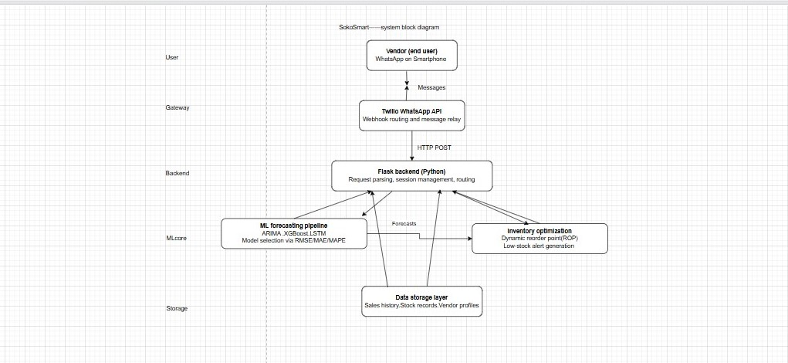
Figure 3 Block diagram
The block diagram above illustrates the five layer architecture of SokoSmart. At the top, the vendor layer represents the end user interacting with the system exclusively through WhatsApp on a smartphone no additional software or hardware is required. The gateway layer consists of the Twilio WhatsApp Business API, which receives incoming vendor messages and routes them to the system backend via HTTP POST webhooks, and relays system responses back to the vendor's WhatsApp. The backend layer is a Flask application written in Python that handles request parsing, session management, and routing between system components. The ML core layer contains two parallel components the forecasting pipeline, which runs the models and selects the best performer based on RMSE, MAE, and MAPE evaluation, and the inventory optimization engine, which consumes forecast outputs to compute dynamic reorder points and generate low stock alerts. The storage layer maintains vendor sales history, current stock records, and vendor profiles used for model training and reorder calculations. Bidirectional arrows between the backend and storage layer indicate that data is both written during vendor input sessions and read during forecast generation cycles.
To ensure system resilience under model failure or insufficient training data, the ML forecasting pipeline implements a fallback heuristic: if all three models produce an invalid output or if the vendor's historical record contains fewer than 30 data points, the system defaults to a 30 day simple moving average calculated directly from available sales records. This guarantees that forecast queries always return a usable estimate while the ML pipeline is training or retraining. Models are scheduled for weekly retraining every Sunday at 2:00 AM EAT, or on demand when a vendor accumulates 50 new sales records since the last training cycle, whichever occurs first.

3.3.3 Data Flow Diagram
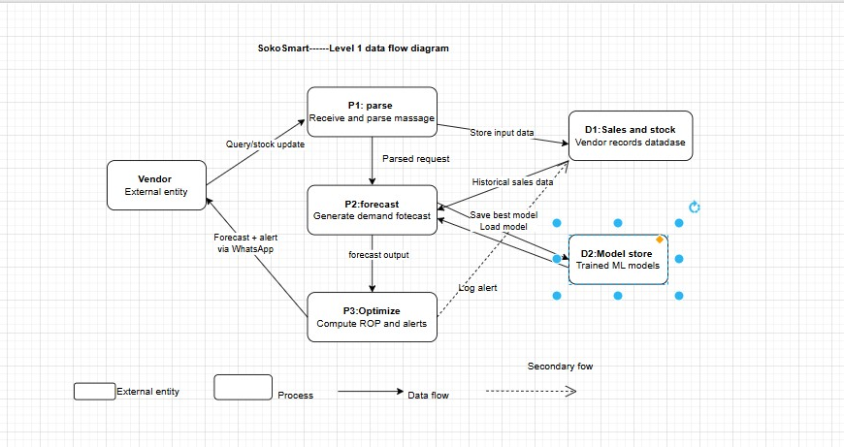
Figure 4 Data Flow Diagram
The Level 1 Data Flow Diagram maps the movement of data through SokoSmart from vendor input to system output. The vendor, represented as the sole external entity, initiates all data flows by sending a WhatsApp message either a stock update, a forecast query, or a stock status query. This message is received by Process 1 (Parse), which validates and parses the input and writes any new stock or sales data to Data Store D1, the vendor records database. The parsed request is passed to Process 2 (Forecast), which reads historical sales data from D1 and loads the pretrained best performing model from Data Store D2, the model store. After generating the demand forecast, P2 writes the updated model selection back to D2. The forecast output is passed to Process 3 (Optimize), which computes the dynamic reorder point and determines whether a low stock alert should be triggered. P3 returns the forecast result and any alerts to the vendor via WhatsApp, and logs the alert event to D1 as a secondary data flow. This diagram confirms that the vendor is the only external actor in the system all data transformations occur internally within the SokoSmart pipeline.

3.3.4 Entity Relationship Diagram
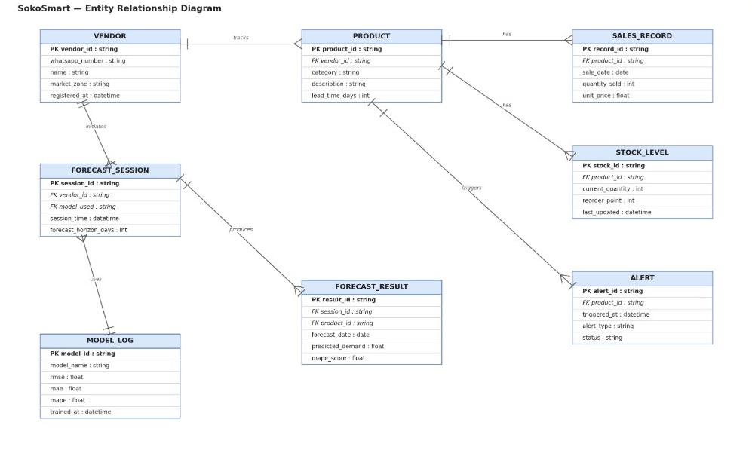
Figure 5 Entity relationship diagram
The Entity Relationship Diagram defines the eight core entities in SokoSmart's data layer and the relationships between them. The VENDOR entity is the central actor, identified by a unique vendor ID linked to their WhatsApp number and market zone. Each vendor tracks one or more PRODUCTs, each of which carries a lead time field used in reorder point calculations. Every product maintains SALES_RECORDs individual transaction entries recording quantity sold and date and a STOCK_LEVEL entry that holds the current quantity and the dynamically computed reorder point. When stock falls at or below the reorder point, an ALERT entity is created for that product, recording the trigger time and alert status. Vendors also initiate FORECAST_SESSIONs, each linked to a specific MODEL_LOG entry recording which model was selected and its accuracy scores (RMSE, MAE, MAPE). Each session produces one or more FORECAST_RESULTs predicted demand figures per product per future date. The cardinality notations confirm that one vendor can track many products, one product can have many sales records and one stock level entry, and one forecast session can produce many forecast results.

3.3.5 Data Dictionary
Table X presents the data dictionary for SokoSmart's core entities, defining each field's data type, constraints, and purpose.
Table 5 Data Dictionary
Entity | Attribute | Data Type | Constraints | Description
VENDOR | vendor\_id | string | PK, unique | Unique system identifier for each vendor
VENDOR | whatsapp\_number | string | unique, not null | Vendor's registered WhatsApp number (E.164 format)
VENDOR | name | string | not null | Vendor's business or personal name
VENDOR | market\_zone | string | not null | Market location: Gikomba, Eastleigh, Toi, or CBD
VENDOR | registered\_at | datetime | auto | Timestamp of account creation
PRODUCT | product\_id | string | PK, unique | Unique product identifier
PRODUCT | vendor\_id | string | FK → VENDOR | Links product to owning vendor
PRODUCT | category | string | not null | Product category (e.g., dresses, shoes)
PRODUCT | description | string | nullable | Optional product details
PRODUCT | lead\_time\_days | int | > 0 | Supplier delivery time in days
SALES\_RECORD | record\_id | string | PK, unique | Unique transaction record ID
SALES\_RECORD | product\_id | string | FK → PRODUCT | Links sale to product
SALES\_RECORD | sale\_date | date | not null | Date of sale transaction
SALES\_RECORD | quantity\_sold | int | ≥ 1 | Units sold in transaction
SALES\_RECORD | unit\_price | float | ≥ 0 | Price per unit in KES
STOCK\_LEVEL | stock\_id | string | PK, unique | Unique stock record ID
STOCK\_LEVEL | product\_id | string | FK → PRODUCT | One-to-one with product
STOCK\_LEVEL | current\_quantity | int | ≥ 0 | Current available stock
STOCK\_LEVEL | reorder\_point | int | ≥ 0 | Dynamically computed threshold
STOCK\_LEVEL | last\_updated | datetime | auto | Last modification timestamp
ALERT | alert\_id | string | PK, unique | Unique alert identifier
ALERT | product\_id | string | FK → PRODUCT | Product triggering alert
ALERT | triggered\_at | datetime | auto | Alert generation timestamp
ALERT | alert\_type | string | not null | Alert classification (e.g., low\_stock)
ALERT | status | string | default 'active' | Alert state: active, dismissed, resolved
FORECAST\_SESSION | session\_id | string | PK, unique | Unique forecast run ID
FORECAST\_SESSION | vendor\_id | string | FK → VENDOR | Requesting vendor
FORECAST\_SESSION | model\_used | string | FK → MODEL\_LOG | Model selected for session
FORECAST\_SESSION | session\_time | datetime | auto | Forecast execution timestamp
FORECAST\_SESSION | forecast\_horizon\_days | int | > 0 | Days ahead predicted
FORECAST\_RESULT | result\_id | string | PK, unique | Unique result entry ID
FORECAST\_RESULT | session\_id | string | FK → FORECAST\_SESSION | Parent forecast session
FORECAST\_RESULT | product\_id | string | FK → PRODUCT | Product forecasted
FORECAST\_RESULT | forecast\_date | date | not null | Specific date of prediction
FORECAST\_RESULT | predicted\_demand | float | ≥ 0 | Forecasted quantity
FORECAST\_RESULT | mape\_score | float | ≥ 0 | Model accuracy for this prediction
MODEL\_LOG | model\_id | string | PK, unique | Unique model identifier
MODEL\_LOG | model\_name | string | not null | Model type: ARIMA, XGBoost, LSTM
MODEL\_LOG | rmse | float | ≥ 0 | Root Mean Square Error
MODEL\_LOG | mae | float | ≥ 0 | Mean Absolute Error
MODEL\_LOG | mape | float | ≥ 0 | Mean Absolute Percentage Error
MODEL\_LOG | trained\_at | datetime | auto | Model training timestamp

3.4 Technical Requirements
This section outlines the hardware, software, and network requirements necessary for both the development of SokoSmart and its deployment and use in the target environment. Requirements are separated into two categories: development requirements, which apply to the researcher building the system, and end-user requirements, which apply to vendors accessing the system through WhatsApp.

3.4.1 Development Requirements
The following tools, languages, frameworks, and hardware are required to build, train, and deploy SokoSmart.

Hardware Requirements (Development)
Table 6 Hardware Requirements
Component | Minimum Specification | Recommended Specification
Processor | Intel Core i5 / AMD Ryzen 5 (8th gen+) | Intel Core i7 / AMD Ryzen 7
RAM | 8 GB | 16 GB
Storage | 256 GB SSD | 512 GB SSD
Operating System | Windows 10 / Ubuntu 20.04 / macOS 11 | Windows 11 / Ubuntu 22.04
Internet connection | Broadband (10 Mbps+) | Broadband (25 Mbps+)

The RAM requirement of 8 GB minimum is driven by the computational demands of training LSTM neural networks locally. For LSTM training specifically, 16 GB is strongly recommended to avoid memory overflow during model fitting on larger datasets. Alternatively, Google Colaboratory provides free cloud-based GPU access that eliminates local hardware constraints for model training (Bisong, 2019).

Programming Languages
Table 7 programming languages
Language | Version | Purpose
Python | 3.10+ | Core development language for ML pipeline, Flask backend, and data processing
HTML / CSS | HTML5 / CSS3 | Basic frontend for any administrative interface or documentation pages
JSON | — | Data interchange format between Flask API and Twilio webhook
Python is selected as the sole core programming language for SokoSmart based on its dominance in the machine learning ecosystem, its extensive library support for time-series forecasting and deep learning, and its compatibility with the Flask web framework used for API development (Géron, 2022).

Frameworks and Libraries
Table 8 Frameworks and Libraries
Library / Framework | Version | Purpose
Flask | 3.0+ | Backend web framework for API routing and webhook handling
scikit-learn | 1.4+ | ARIMA preprocessing, model evaluation metrics (RMSE, MAE, MAPE)
statsmodels | 0.14+ | ARIMA and SARIMA model implementation
XGBoost | 2.0+ | XGBoost gradient boosting model implementation
TensorFlow / Keras | 2.15+ | LSTM neural network model implementation
Pandas | 2.0+ | Data loading, cleaning, and transformation
NumPy | 1.26+ | Numerical computation and array operations
Matplotlib / Seaborn | 3.8+ / 0.13+ | Data visualization for model evaluation and EDA
Twilio Python SDK | 8.0+ | WhatsApp message sending and receiving via Twilio API
python-dotenv | 1.0+ | Environment variable management for API keys and secrets
pytest | 7.0+ | Automated unit and integration testing

Development Tools
Table 9 Development Tools
Tool | Purpose
Jupyter Notebook / Google Colab | Interactive model development, training, and evaluation
Visual Studio Code | Primary code editor for Flask backend and chatbot development
Git / GitHub | Version control and code repository management
Postman | API endpoint testing before Twilio integration
ngrok | Local Flask server tunnelling for Twilio webhook testing during development
Mendeley Desktop | Reference management for project documentation
Microsoft Word | Project documentation authoring
Cloud Deployment Tools
Table 10 Cloud Deployment Tools
Tool | Purpose
Render / Railway | Cloud hosting for Flask application deployment
Twilio Console | WhatsApp sandbox configuration and message log monitoring
GitHub Actions (optional) | Continuous integration and automated deployment pipeline

3.4.1.A Security Architecture

Security is handled at three levels. First, transport: every message between Twilio and the Flask backend travels over HTTPS with TLS 1.3, and I validate Twilio's webhook signature on every request to block spoofing. Second, data: vendor records are encrypted at rest through AES-256, which Render and Railway provide by default on their managed databases. WhatsApp numbers are hashed with SHA-256 inside my system; the original number only lives in Twilio's sandbox. Third, application: I use SQLAlchemy ORM for all database queries, which parameterises inputs automatically and prevents injection. I also do not send any vendor data to third-party analytics. This setup meets Kenya's Data Protection Act 2019 standards for lawful processing and data minimisation (Republic of Kenya, 2019).

3.4.2 End-User Requirements
SokoSmart is explicitly designed to impose minimal requirements on the end user. The following specifications define the minimum environment required for a vendor to access and use the system.

Hardware Requirements (End User)
Table 11 Hardware requirements
Component | Minimum Requirement
Device | Android smartphone (Android 5.0+) or iPhone (iOS 12+)
RAM | 2 GB
Storage | 100 MB free space (for WhatsApp only)
Data connection | Mobile data (2G minimum; 3G or 4G recommended for response speed)
Screen | Any screen size capable of running WhatsApp

No laptop, desktop computer, POS system, barcode scanner, or any additional hardware is required. The vendor's existing smartphone running WhatsApp is the only hardware requirement (Communications Authority of Kenya, 2024).

Software Requirements (End User)
Table 12 Software Requirements
Software | Version | Notes
WhatsApp Messenger | 2.21+ | Available free on Google Play Store and Apple App Store
Internet browser | Any | Required only if vendor accesses any optional web-based help documentation
No Python installation, no app download beyond WhatsApp, and no technical configuration is required from the vendor. The system is entirely server-side all computation occurs on the cloud-hosted Flask backend.

Connectivity Requirements (End User)
SokoSmart's WhatsApp interface is designed to function on standard mobile data as available across Nairobi's market zones. The (Communications Authority of Kenya, 2024) confirms that 3G and 4G coverage is near universal in Nairobi County, meaning the connectivity requirement is met by the existing infrastructure in all four target market zones. WhatsApp's offline message queuing feature additionally ensures that alerts generated while a vendor's phone is temporarily offline are delivered upon reconnection, providing resilience in low connectivity moments.

3.5 Project Budget
This section presents the estimated budget for developing and deploying SokoSmart. Costs are categorised into software and tools, cloud infrastructure, data acquisition, and miscellaneous expenses. All figures are quoted in Kenyan Shillings (KES) and reflect student pricing or free-tier availability where applicable.
Table 13 Budget
Item | Description | Unit Cost (KES) | Quantity | Total (KES)
Development laptop | Existing personal equipment (depreciation excluded) | 0 | 1 | 0
Internet connectivity | Home broadband for development period | 3,000/month | 3 months | 9,000
Twilio WhatsApp API | Sandbox usage free; testing credits for message volume | 2,000 | 1 | 2,000
Cloud hosting (Render/Railway) | Free tier sufficient for prototype; paid tier contingency | 0 (free tier) | 1 | 0
Python libraries | Open source (scikit-learn, TensorFlow, Flask, etc.) | 0 | — | 0
Datasets | Publicly available fashion retail datasets | 0 | — | 0
Reference materials | Journal access via university library subscription | 0 | — | 0
Printing and binding | Final project report production | 1,500 | 1 | 1,500
Contingency (10%) | Unforeseen expenses | — | — | 1,250
**Grand Total** |  |  |  | **13,750**
The budget totals KES 13,750, well within the affordability constraint established in NFR6 (KES 2,000 monthly operational cost). The largest single expense is internet connectivity, which is already a sunk cost for most students. Cloud hosting is absorbed through free-tier services, and all software is open-source. This cost structure confirms that SokoSmart is financially viable for both development and eventual deployment to micro-vendors who cannot absorb subscription fees.

3.6 PROJECT TIMELINE (GANTT CHART)
The project schedule spans 10 weeks, aligned with the Agile Scrum framework described in Section 3.1. Table X maps each sprint to specific deliverables, milestones, and dependencies.
Table 14 Gantt Chart SokoSmart Development Schedule
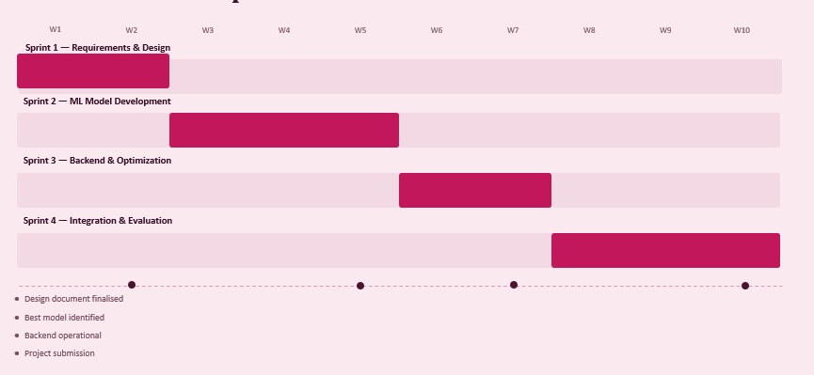
The schedule allows two weeks for requirements and design, three weeks for iterative model development (the longest phase due to training and tuning overhead), two weeks for backend construction, and three weeks for chatbot integration, testing, and final documentation. Week 5 includes a buffer for model selection delays, and Week 9 reserves time for usability testing with representative users. This timeline is realistic given the scope and aligns with the four-sprint Agile structure.

References
Aker, J. C., & Mbiti, I. M. (2010). Mobile phones and economic development in Africa. Journal of Economic Perspectives, 24(3), 207–232. https://doi.org/10.1257/jep.24.3.207
Baryannis, G., Validi, S., Dani, S., & Antoniou, G. (2019). Supply chain risk management and artificial intelligence: State of the art and future research directions. International Journal of Production Research, 57(7), 2179–2202. https://doi.org/10.1080/00207543.2018.1530476
Bisong, E. (2019). Building machine learning and deep learning models on Google Cloud Platform: A comprehensive guide for beginners. Apress. https://doi.org/10.1007/978-1-4842-4470-8
Communications Authority of Kenya. (2024). Quarterly sector statistics report: Quarter 1, 2023/2024. https://www.ca.go.ke
Ferreira, K., Lee, B., & Simchi-Levi, D. (2016). Analytics for an online retailer: Demand forecasting and price optimization. Manufacturing & Service Operations Management, 18(1), 69–88. https://doi.org/10.1287/msom.2015.0561
Fildes, R., Ma, S., & Kolassa, S. (2022). Retail forecasting: Research and practice. International Journal of Forecasting, 38(4), 1283–1318. https://doi.org/10.1016/j.ijforecast.2019.06.004
Géron, A. (2022). Hands-on machine learning with Scikit-Learn, Keras, and TensorFlow (3rd ed.). O’Reilly Media.
Giri, C., Jain, S., Zeng, X., & Bruniaux, P. (2022). Deep learning for demand forecasting in the fashion and apparel retail industry. Forecasting, 4(2), 565–581. https://doi.org/10.3390/forecast4020031
Hollupathirage, I. (2025). A digital twin system for retail inventory and sales management [Master’s thesis, University of Vaasa]. https://urn.fi/URN:NBN:fi-fe20251128112774
IHL Group. (2023). Retail’s $1.75 trillion problem: The impact of out-of-stocks and overstocks. https://www.ihlservices.com
Jack, W., & Suri, T. (2014). Risk sharing and transactions costs: Evidence from Kenya’s mobile money revolution. American Economic Review, 104(1), 183–223. https://doi.org/10.1257/aer.104.1.183
Kharfan, M., Chan, V. W. K., & Okumus, F. (2020). A data-driven forecasting approach for newly launched seasonal products by leveraging machine-learning approaches. Annals of Operations Research, 303, 159–187. https://doi.org/10.1007/s10479-020-03666-w
Loureiro, A. L., Miguéis, V. L., & Da Silva, L. F. (2018). Exploring the use of deep neural networks for sales forecasting in fashion retail. Decision Support Systems, 114, 81–93. https://doi.org/10.1016/j.dss.2018.08.010
Makridakis, S., Spiliotis, E., & Assimakopoulos, V. (2018). Statistical and machine learning forecasting methods: Concerns and ways forward. PLOS ONE, 13(3), e0194889. https://doi.org/10.1371/journal.pone.0194889
Omwenga, E., Waweru, M., & Kamau, J. (2020). Competitive dynamics and survival strategies among micro-retailers in the Nairobi Central Business District. African Journal of Business and Economic Research, 15(2), 112–130. https://doi.org/10.31920/1750-4562/2020/v15n2a6
Pressman, R. S., & Maxim, B. R. (2020). Software engineering: A practitioner’s approach (9th ed.). McGraw-Hill Education.
Ren, S., Chan, H. L., & Siqin, T. (2020). Demand forecasting in retail operations for fashionable products: Methods, practices, and real case study. Annals of Operations Research, 291, 761–777. https://doi.org/10.1007/s10479-019-03148-8
Republic of Kenya. (2019). Data Protection Act, 2019. https://kenyalaw.org/kl/fileadmin/pdfdownloads/Acts/2019/TheDataProtectionAct__No24of2019.pdf
Selamat, M. A. A., & Windasari, N. A. (2021). Chatbot for SMEs: Integrating customer and business owner perspectives. Technology in Society, 66, 101685. https://doi.org/10.1016/j.techsoc.2021.101685
Seyedan, M., Mafakheri, F., & Wang, C. (2023). Order-up-to-level inventory optimization model using time-series demand forecasting with ensemble deep learning. Supply Chain Analytics, 3, 100024. https://doi.org/10.1016/j.sca.2023.100024
Sommerville, I. (2016). Software engineering (10th ed.). Pearson Education.
Swaminathan, K., Wang, X., Goh, M., Li, J., Zhang, S., Liu, Y., Zheng, S., & Chen, S. (2023). Demand forecasting for fashion products: A systematic review. International Journal of Forecasting. https://doi.org/10.1016/j.ijforecast.2022.08.001
Wanjiru, R., & Ngugi, B. (2021). Inventory management practices and financial performance of small and medium enterprises in Nairobi County, Kenya. Journal of Business and Management, 23(1), 45–58. https://doi.org/10.9790/487X-2301024558

APPENDIX A: STRUCTURED OBSERVATION NOTES

A.1 Observation Protocol and Method
I observed eight fashion vendors in four Nairobi markets: Gikomba, Eastleigh, Toi Market, and Nairobi CBD. Two vendors were observed in each market between 15 and 20 July 2026. I looked at how they kept track of stock, when they decided to buy more stock, what happened when items were left unsold or ran out, and how they used their phones in the business. I did not record vendor names, stall numbers, photographs, or personal information.

A.2 Observation Notes
Gikomba Market
Vendor G1; Mitumba clothing
- Used a small notebook to keep track of stock.
- When jeans started running low, the vendor judged the amount left rather than doing an actual count.
- Three unopened bales of children's sweaters were behind the stall. The vendor said they had been bought the previous month when the weather was cold but were no longer selling well.
- A customer asked for size 34 men's jeans, but the vendor did not have any and directed the customer to another stall.
- The vendor had a Tecno phone and was using WhatsApp to communicate with a supplier.
Vendor G2; Women's dresses and tops
- Did not have a visible stock record. The vendor counted the remaining black dresses aloud when asked.
- She said she normally restocked on Saturdays based on what looked low.
- Some floral blouses were still on the rack even though they had been marked down from KES 800 to KES 300. The vendor said they were from December and the trend had changed.
- She used WhatsApp Business to show customers product photos, but the catalogue was not connected to her stock records.
Eastleigh Market
Vendor E1; Men's shirts and trousers
- Used the Notes app on a Samsung phone to keep a list of some stock.
- The list had quantities for different shirts and trousers but had no dates. The vendor said it had not been updated for about two weeks.
- A customer asked for size 34 trousers, but none were available. The vendor immediately sent a WhatsApp voice note to a supplier asking for four pairs.
- A carton of leather belts bought during Ramadan was still unopened.
- The vendor was comfortable using WhatsApp for supplier communication and customer messages.
Vendor E2; Women's hijabs and modest wear
- Shared a notebook with her sister, who operated another stall nearby.
- Some stock figures in the notebook did not match the physical stock, and several entries had been crossed out.
- A customer asked for navy-blue school hijabs, but the vendor said they had finished the previous day.
- The vendor estimated that the shortage had cost about KES 8,000 during the back-to-school period.
- WhatsApp was used for supplier orders and customer inquiries.
Toi Market
Vendor T1; Children's clothing
- Did not use a notebook or phone application to record stock.
- When asked how she decided what to buy, she said, "Najua biashara yangu" (I know my business).
- The 0–3 month baby rompers were still in good supply, while the 6–9 month section was almost empty.
- The vendor said she would go to Gikomba to buy more stock when she had enough money.
- Some of the 0–3 month rompers had dust on their packaging. She said customers were now buying bigger sizes and she had not noticed the change early enough.
- She used a basic Tecno phone and mainly used WhatsApp for receiving messages.
Vendor T2; Shoes
- Used a school exercise book with tally marks to record sales.
- The pages were divided by shoe type, but there were no dates.
- He restocked popular sizes when the tally became low but sometimes continued ordering slow-moving sizes.
- Several pairs of large men's formal shoes had remained on a high shelf and were covered with dust.
- He received supplier photos through WhatsApp and preferred voice notes to typing.
Nairobi CBD
Vendor C1; Office wear and formal shirts
- Used a spreadsheet on a phone, but the spreadsheet was maintained by a nephew who visited on weekends.
- The vendor sent stock changes to the nephew through WhatsApp.
- Some blazers bought for the December period were still in stock and had been reduced from KES 3,500 to KES 1,500.
- White shirts in size 16.5 regularly ran out, but the order quantity was not increased.
- The vendor was comfortable using WhatsApp.
Vendor C2; Casual wear
- Did not use a visible stock record and relied mainly on experience.
- The vendor normally travelled to River Road suppliers on Monday mornings with money saved from the weekend.
- Some graphic T-shirts had become difficult to sell after the trend changed.
- The vendor said jeans in sizes 32 and 34 regularly ran out around the end of the month.
- WhatsApp was mainly used for family communication, and the vendor was doubtful about using business applications.

A.3 Main Findings from the Observations
The observations showed that the vendors used different methods to keep track of stock, but none of the eight vendors was using a dedicated inventory management system. Some relied on notebooks or exercise books, while others used phone notes, spreadsheets maintained by someone else, or memory.
Stock was usually reordered after it became low or when a customer asked for an item that was unavailable. There were also examples of products remaining unsold after trends or seasonal demand had changed. At the same time, some vendors regularly ran out of particular sizes during periods of higher demand.
WhatsApp was already familiar to the vendors, mainly for communicating with customers and suppliers. However, their comfort with typing and other phone-based tasks differed. These observations helped me identify the need for a simple inventory system that could provide demand forecasts and reorder alerts through a platform the vendors already use.

